**Creating Microservices for account and loan**

**Account Microservice**

SETUP & PROGRAM :

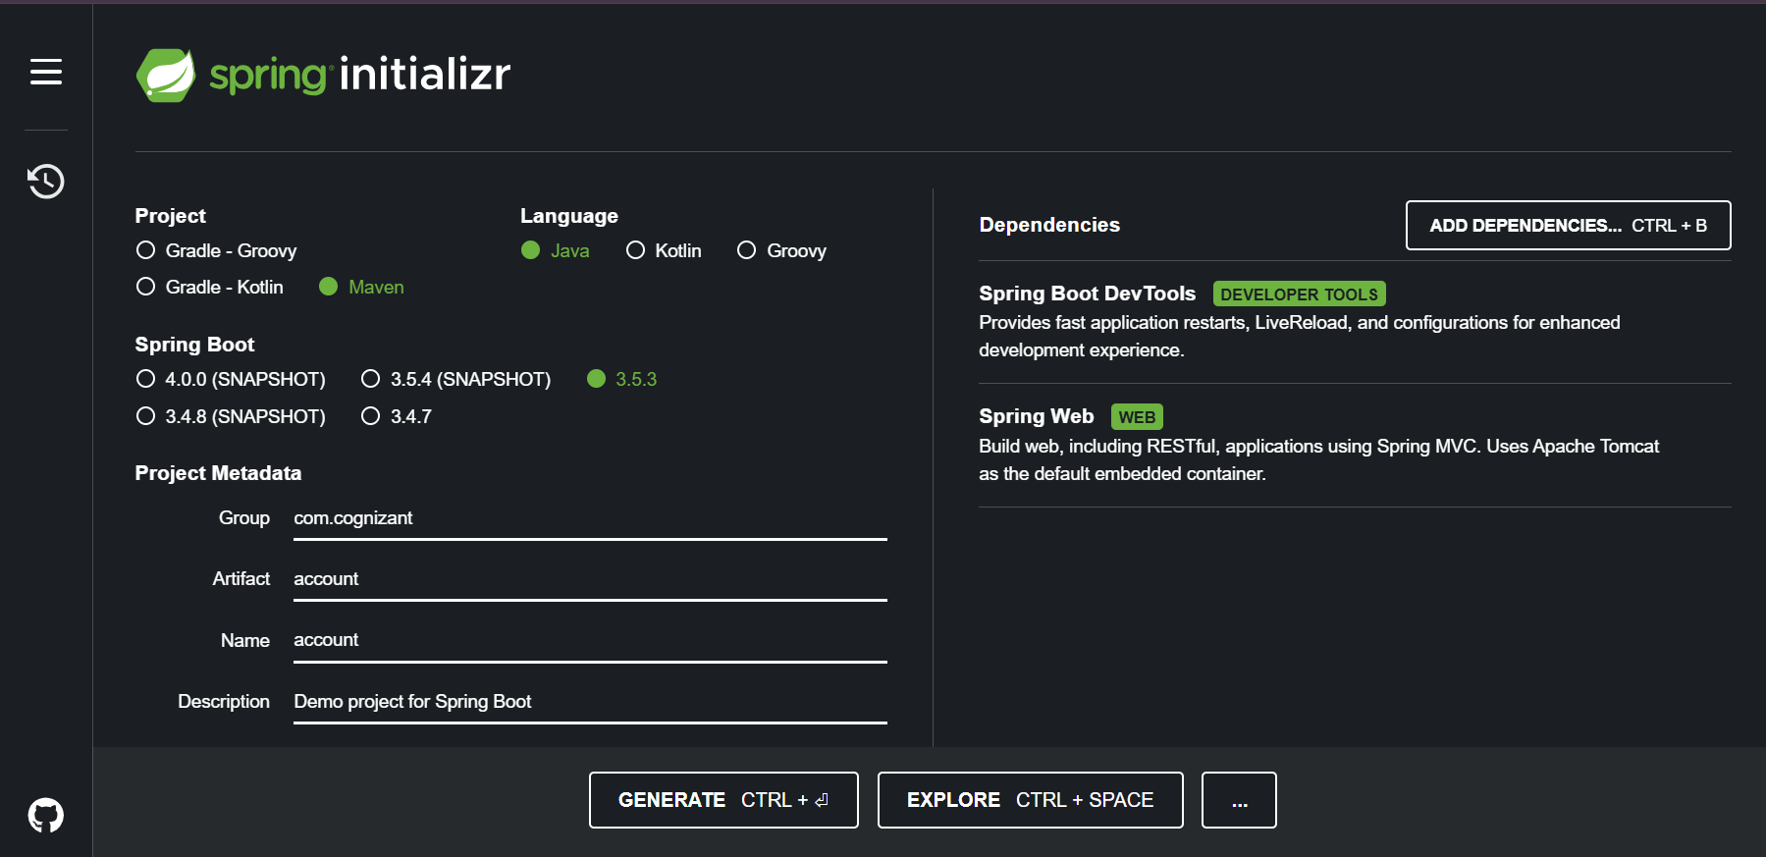

//AccountController.java

package com.cognizant.account.controller;

import org.springframework.web.bind.annotation.*;

import java.util.Map;

*@RestController*

*@RequestMapping*("/accounts")

public class AccountController {

*@GetMapping*("/{number}")

public Map<String, Object> getAccount(*@PathVariable* String number) {

return Map.*of*(

"number", number,

"type", "savings",

"balance", 234343

);

}

}

OUTPUT:

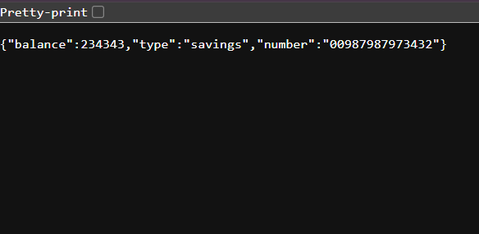

**Loan Microservice**

PROGRAM:

//LoanController.java

package com.cognizant.loan.controller;

import org.springframework.web.bind.annotation.*;

import java.util.Map;

*@RestController*

*@RequestMapping*("/loans")

public class LoanController {

*@GetMapping*("/{number}")

public Map<String, Object> getLoan(*@PathVariable* String number) {

return Map.*of*(

"number", number,

"type", "car",

"loan", 400000,

"emi", 3258,

"tenure", 18

);

}

}

OUTPUT:

